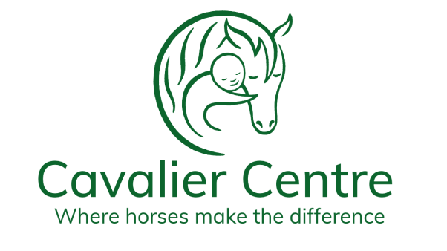

APPLICATION FORM
Volunteer and Participant Coordinator

Title
Name
Telephone
Email
Address & postcode

Summary of Education and Qualifications. Include name of School, College or University, Dates and Type of qualification and level/grade
Name | Dates Attended | Qualifications | Grades/Level

Volunteer roles (feel free to include more lines):
Name of Organisation and Dates | Activity /Role

Please state why you should be considered for the position, what attributes you have to support it and other relevant information including volunteer roles.

By providing us with current and previous employment details, you give us consent to contact them as referees.
Where did you hear about this job opportunity :
Closing date: 9am 24th March 2022
Please send this completed application form along with a copy of your CV to:
Rachel Lambert-Jones, Centre Manager, Cavalier Centre centremanager@cavaliercentre.org.uk
Please refer to our GDPR statement on our website

